By: Mera AL-Salhi 22110377

Explainable Machine Learning for Gallstone Disease Prediction
Technical Report
Course: Machine Learning– Fall 2025/2026
Course instructor: Rami AL-Ouran

Data Preparation and Description (Q1)

Data Description
Thiscdataset((gallstone disease))considered somehow common,(Gallstoneodisease)is a prevalent(gastrointestinal)disorder,(which)develops when hard deposits are created within the gallbladder. The(clinical)significance(of)early diagnosis is that an undiagnosed gallstone may cause a complication in the form of inflammation, infection, or bile duct blockage. The machine(learning)provides)a
)statistically-drivennsolution to determine the risk patterns using the clinical and body-composition characteristics, helping clinicians to make decisions.
In this project, four-machine-learning models, namely)Logistic(Regression, DecisiontTree, Random Forest and XGBoost are developed, tunedoand evaluated topinfer whether the patient has gallstones or not. The given study adheres to the machine learning pipeline that is needed in the assignment brief, including the data preparation, implemented model hyperparameter optimization, test set evaluation, bias-variance analysis, and explainable machine learning.
It consist of 319 patient sample and 39 feature which:
- Demographic features: Age, Gender
- Clinical conditions: Diabetes Mellitus, Coronary Artery Disease, Hypothyroidism, Hyperlipidemia
- Body composition metrics: BMI, Total Body Water, Visceral Fat Area, Muscle Mass, Bone Mass, HDL/LDL, Triglycerides, etc.
- Biochemical measures: Glucose, ALT, AST, Vitamin D, ALP, Creatinine
- Target column: Gallstone Status (0 = no gallstones, 1 = gallstones)
This task represents a binary supervised classification problem, where the objective is to predict whether a patient has gallstones based on the provided features.

Data Preparation

Checking Data Quality
The following checks were performed:
- df.info() → 319 non-null values for every feature
- df.isna().sum() → 0 missing values across all 39 columns
- Data types: mixture of integer and float features
- No categorical string variables were present
Therefore, As a result, no missing-value imputation or data cleaning was required, reducing the risk of introducing bias through artificial data manipulation.

Encoding and Feature Scaling
- The data set did not have categorical variables that were in form of strings; hence, no encoding was necessary. Label encoding was implemented as a precaution measure to ascertain utmost compatibility with the machine learning algorithms..

- The scaling of numerical features was done with StandardScaler that scales features in terms of deviation to a normal value of zero and unit variance. This step is especially essential to models that are based on optimization like Logistic Regression as it enhances the stability of convergence and makes all the features proportionate to theelearning process..

Exploratory Data Analysis
Exploratoryadata)analysis(was performed in order to know the feature distributions and relationship.
Descriptive statistics:
df.describe() revealed meaningful variation across clinical metrics (e.g., triglycerides ranging from 1.39 to 838 mg/dL).
Correlation heatmap
A heatmap showed:
- Close associations between variables of body composition (VFA, TBW, ECW, ICW)
- Moderate relations between cholesterol-related measures.
- The target column "Gallstone Status" showed mild but notable correlations with certain metabolic indicators

Train–Test Split
In order to assess the performance of model generalization, an 80% 20% split of the data was used to make the training and testing data sets, wityyh random estate=42to provide reproducibility. The model learning and hyperparameter optimization were performed on the training sset and unbiased prediction was performed in test set. This division is critical in ensuring that information does not leak out and also to get a realistic estimation of the model performance in practical settings.

Model Implementation (Q2)

Table 1: Description of the hyperparameters and values considered.
Algorithm | Hyperparameter | Description | Values considered
Logistic Regression | c | determines how much the model prioritizes fitting the training data, small c = strong regularization and large C = weak reg | {0.01, 0.1, 1, 10}
Logistic Regression | penalty | Type of regularization applied , it h elps prevent overfitting by constraining the(magnitude of the model’s coefficients | {L1, L2}
Decision Tree | Max_depth | max allowed depth of the tree
  {3, 5, 7, None}
Decision Tree | Min_sample_split | min samples required to split a node | {2, 5, 10}
Decision Tree | Min_Samples_leaf | min samples required at a leaf node | {1, 2, 4}
Random forest | N_estimators | Number of trees in the forest | {50,100}
Random forest | Max_depth | max depth of each tree | {5,10,None}
Random forest | Max_features | nnumber of features considered at each split | {sqrt, log2}
Random forest | Min_sampels_split | Minimum samples required to split a node | {2, 5}
XGBoost | N_estimators | Number of boosting trees | {50, 100}
XGBoost | Max_depth | Maximum depth of decision tree is allowed to grow | {3, 5, 7}
XGBoost | Learning_rate | Step size shrinkage | {0.01, 0.1, 0.2}
XGBoost | subsample | Fraction o fthe samples used-per(tree | {0.8, 1.0}

Table 2: Combination of the hyperparameter values and corresponding performance achieved.
Algorithm | Combination of hyperparameter values | Training performance | Validation performance
Logistic Regression | C= 0.1 , penalty=L2 | 1.0000 | 0.7725
Decision Tree | Max_depth=3,  Min_samples_leaf=4,  Min_samples_split=2 | 1.0000 | 0.6980
Random forest | N_estimators=100,  Max_depth=5,  Max_features=log2,  Min_samples_split=5 | 1.0000 | 0.7882
XGBoost | N_esimators=100,  Max_depth=5,  Learning_rate=0.2,  Subsample=0.8 | 1.0000 | 0.7765

Model Testing and Evaluation (Q3)

Table 3: Summary of the test results.
Algorithm | Best combination of hyperparams | Test accuracy | Test precision | Test recall | Test f1-score
Logistic Regression | C=0.1, penalty=L2 |  | 0.7857 | 0.7087 | 0.7458
  0.7656
Decision Tree | Max_depth=3,  Min_samples_leaf=4 | 0.6563 | 0.7368 | 0.4516 | 0.5600
Random forest | N_estimators=100,  Max_depth=5,  Max_features=log2 | 0.7969 | 0.7813 | 0.8065 | 0.7937
XGBoost | N_estimators=100  Max_depth=5  Learning_rate | 0.8438 | 0.8621 | 0.8065 | 0.83333

Bias and Variance (Q4)
Bias and variance are two aspects that characterize the two major causes of error in machine learning models. Bias is defined as the mistakes that can be reduced by too simple assumptions in the learning algorithm whereas variance is defined as the mistakes which can be decreased by excessive sensitivity of the learning algorithm to variations in the training data. A good model would seek to strike a balance between the two, which is referred to as bias-variance trade off.
Various algorithms have been tested in this research having varying bias and variance properties. The bias and variance of Logistic Regression were relatively high and low respectively. The reason behind this is that it uses a linear decision boundary that might not be considered complex enough to explain relationships in the data. Consequently, it performed averagely and was weakly flexible, which implied underfitting in certain settings.
Decision tree model had low bias and high variance. As decision trees may be deep, and thus, represent complex decision boundaries, they can model the training data quite accurately. This flexibility however, renders them sensitive to noise and subject to overfitting which was demonstrated by its low performance in tests relative to the ensemble methods.
Random Forest minimized variance by aggregating a number of decision trees that are trained using various bootstrap samples, as well as random subsamples of features. Random Forest averages the predictions of many trees, thereby reducing the instability of a single tree but the bias is also low. The effect of this was enhanced generalization performance than that of an individual decision tree.
XGBoost also enhanced the bias-variance trade-off by adopting the concept of sequence learning. The new tree aims at fixing all the mistakes of the last ensemble enabling the model to minimize bias and contain variance using regularization methods like learning rate decay and subsampling. As a result, XGBoost demonstrated the highest overall performance on the test set, which means that it has a good compromise between bias and variance.
Finally, it is important to note that simpler models like Logistic Regression are likely to experience high bias whereas more complex models like Decision Trees are likely to experience high variance. The ensemble approaches, especially boosting-based algorithms such as XGBoost, offer a suitable process to trade-off between bias and variance resulting in the high predictive accuracy.

Model effectiveness analysis (Q5)
Performance-metrics such as accuracy+precision+recall,f1-score, and confusion matricies are evaluated as model effectiveness since the way in which a trained model will perform on unseen data is determined and the reliability of its predictions to the given problem is also considered and not only by looking at the accuracy of+the model.
Decision tree model presented the least effectiveness of all the algorithms tested. It could fit the training data very well, but the results on the test were much worse especially in the recall and F1-score. This means that the model was overfitting and could not make good generalizations to unknown data.
Logistic Regression proved to be relatively effective. Though it was reasonable in terms of accuracy and precision, its recall was worse than that of ensemble. This indicates that the linear decision boundary Logistic Regression makes was restrictive to its capability to identify more intricate relationships in the data, which resulted in a few misclassifications.
Random Forest model showed good and balanced results in all measures of evaluation. Random Forest reduced variance, and it enhanced generalization by-averaging+the predictions of several decision trees that have been trained on some bootstrap samples as well as different random feature subsets. Its recall and F1-score were relatively high, which means that it was successful to identify both classes correctly without being overly biased to one outcome.
The overall usefulness was the highest in XGBoost. It had the highest test accuracy and the F1-score, high values of precision and recall. This shows that XGBoost achieved good balance between false positives and false negatives as well as classifying most of the samples correctly. Boosting, control of learning rate and regularization allowed the XGBoost to make the correction to the error made in previous steps and overcome overfitting.
Overall, ensemble techniques were more suitable compared to the individual models to this task. XGBoost was the most successful of all assessed algorithms, which is why it was chosen as the most appropriate to predict the status of gallstones by the means of the available data.

Model effectiveness evaluation (Q6)

Effectiveness evaluation.

Algorithm | Accuracy | Precision | Recall | F1-score | Effectiveness Summary
Logistic Regression | 0.7656 | 0.7857 | 0.7097 | 0.7458 | Moderate, linear model with balanced but limited recall
Decision Tree | 0.6563 | 0.7368 | 0.4516 | 0.5600 | Weak generalization due to overfitting
Random Forest | 0.7969 | 0.7813 | 0.8065 | 0.7937 | Strong, balanced ensemble performance
XGBoost | 0.8438 | 0.8621 | 0.8065 | 0.8333 | Best overall performance

The effectiveness of the developed machine learning models was evaluated using unseen test data to ensure fair and unbiased assessment. Multiple evaluation metrics i used including accuracy, precision, recall, F1-score+ and confusion matrices as relying on a single metric may provide a misleading view of model performance, especially in medical classification tasks.
Accuracy+was used to-measure the-overall correctness-of predictions, while precision quantified the proportion of correct positive predictions. Recall was particularly important in this context, as it reflects the modelss ability to correctly identify patients with gallstones. The(F1-score)was used to(balance-precision and recall providing a more robust indicator of effectiveness.
The evaluation results showed that XGBoost achieved the highest effectiveness, outperforming all other models across most metrics. It demonstrated strong precision and recall, indicating reliable detection of both positive and negative cases. Random Forest also showed good generalization ability, achieving balanced performance due to its ensemble nature.
In contrast, the Decision Tree model showed lower effectiveness, primarily due to overfitting, which resulted in reduced recall and F1-score. Logistic Regression achieved moderate performance but was limited by its linear decision boundary. Overall, ensemble-based models proved more effective, with XGBoost identified as the most suitable algorithm for gallstone prediction.

Explainable ML techniques
In order to$improve the level of transparency$and interpretability of the final predictive model, explainable machine learning methods were employed by applying SHAP and LIME. These techniques were applied to describe both the global model behaviour and individual patient-level predictions, which is specifically important in the decision support system related to healthcare.
Global Explainability with SHAp
SHAP summaries and values of the mean absolute SHAP indicate that the most significant feature is C-Reactive Protein (CRP), next comes Vitamin D, Obesity (percent), AST. Increased values of CRP and obesity are likely to promote the presence of gallstones, and Vitamin D decreased values also contribute to high risks. These findings show that the model is based on clinically meaningful aspects.
Local Explainability using SHAP
The SHAP force plot of an individual patient indicates a probability of Gallstones prediction of 0.87. Low Vitamin D, high Obesity (%) and high CRP were the major factors of this prediction forcing the prediction to the gallstone class. There was less of the opposing effect of other features like Bone Mass and Body Protein Content.
Local Explainability using LIME
SHAP predictions were validated by LIME explanations, which indicated the presence of similar decision rules, i.e. Vitamin D ≤ 12.35, Obesity in a percentage, and Intracellular Water, which had a positive contribution to the prediction of gallstones. The correlation between SHAP and LIME gives the model more confidence in its predictions.
Explainability Results Discussion:
The model was able to have a high degree of interpretability through the use of SHAP and LIME without losing predictive accuracy. SHAP gave a global picture of the importance of features whereas LIME gave an intuitive, instance-level explanation. These explainability methods contribute to increased trust in model decisions and can justify its possible application in clinical decision-making, in which the reasons underlying a prediction decision are as significant as the prediction decision itself.
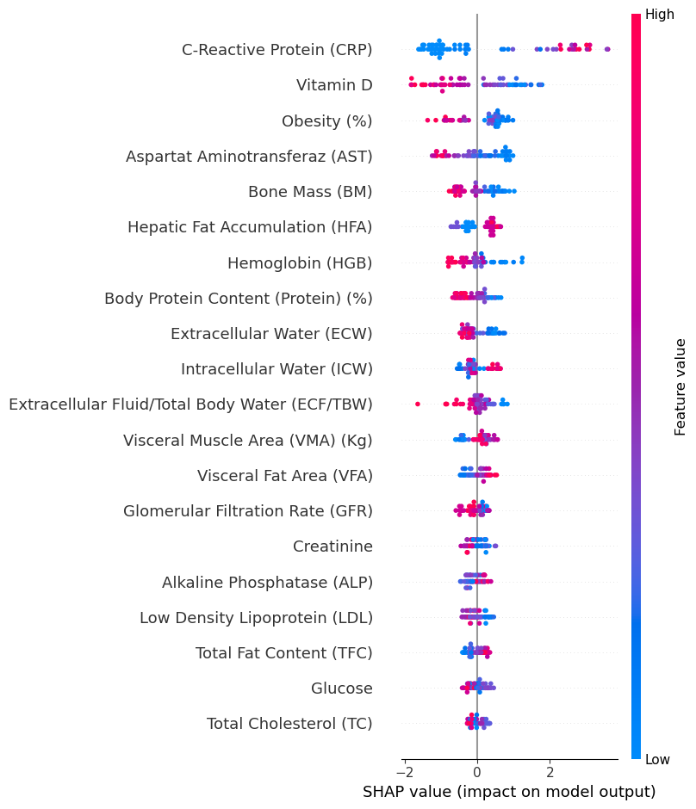
Figure 1: global model explainabilty (SHAP Summary Beeswarm) plot
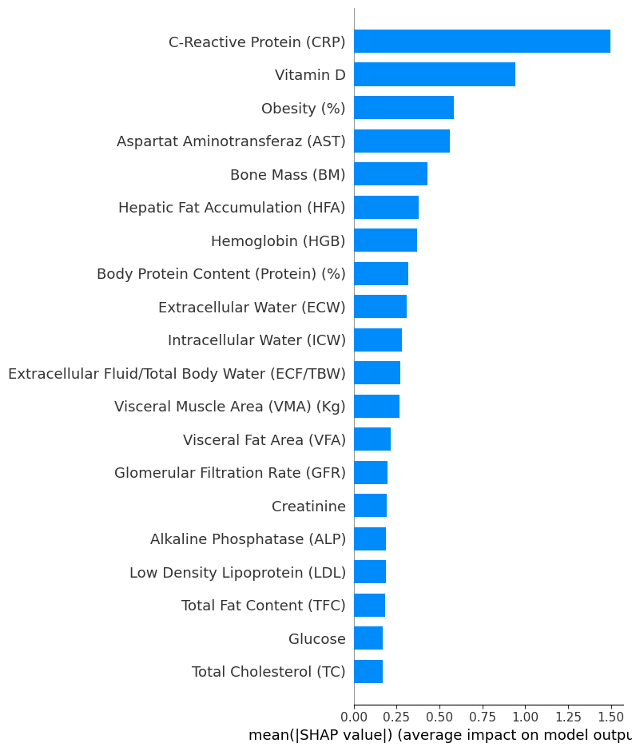
Figure 2: SHAP Mean |SHAP| Bar Plot

Lime: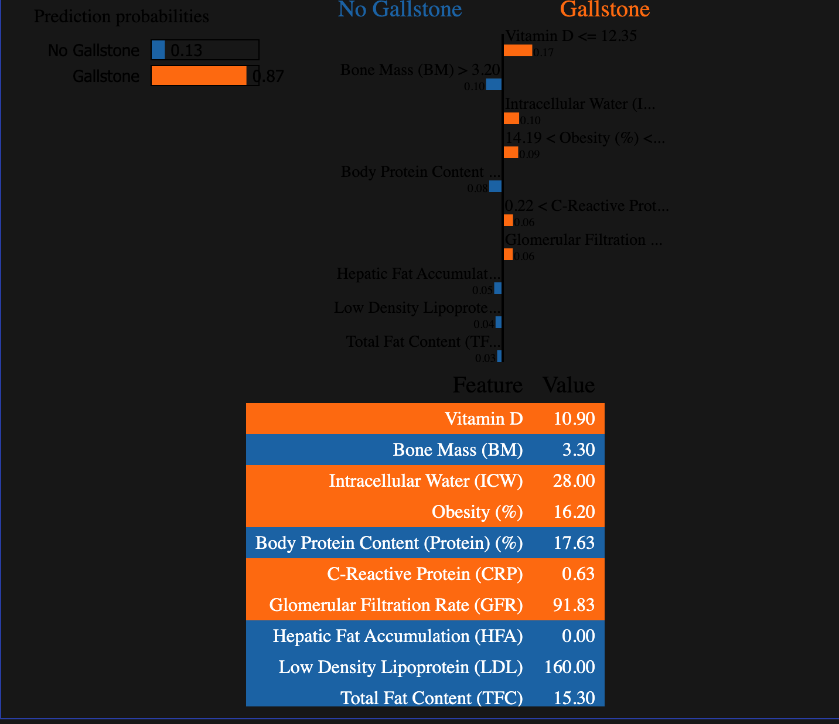
Figure 3: SHAP Force Plot (Prediction probabilities: 0.87 Gallstone)

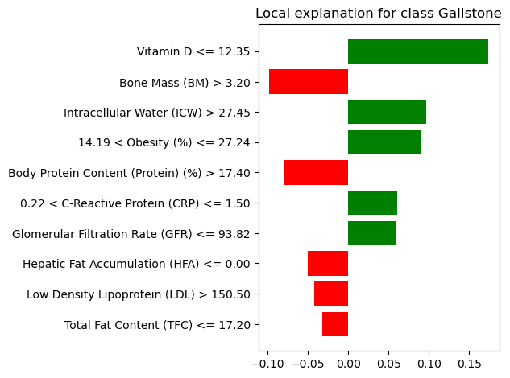
Figure 4: Local Model Explainability (LIME)

Critical evaluation and discussion (Q7)

References
- Scikit-learn, 2025. Logistic Regression. [online] Available at: https://scikit-learn.org/stable/modules/generated/sklearn.linear_model.LogisticRegression.html [Accessed 10 January 2026].
- Scikit-learn, 2025. DecisionTreeClassifier. [online] Available at: https://scikit-learn.org/stable/modules/generated/sklearn.tree.DecisionTreeClassifier.html [Accessed 10 November 2025].
- amartajisce . “Support Vector Machine in Machine Learning.” GeeksforGeeks, 20 Dec. 2020, www.geeksforgeeks.org/support-vector-machine-in-machine-learning/. Accessed 3 Jan. 2026

- Scikit-learn, 2025. RandomForestClassifier. [online] Available at: https://scikit-learn.org/stable/modules/generated/sklearn.ensemble.RandomForestClassifier.html [Accessed 1 December 2025].
- www.baeldung.com/cs/gradient-boosting-trees-vs-random-forests#:~:text=4.3.-. Accessed 12 November. 2025.
- Scikit-learn, 2025. GridSearchCV. [online] Available at: https://scikit-learn.org/stable/modules/generated/sklearn.model_selection.GridSearchCV.html [Accessed 25 November 2025].

